Name | Muhammad Saad Ali
Roll Number | DSAI241103089
Section | 3B

Lab 4: Introduction to Cisco Packet Tracer

Objective:
The objective of this lab is to familiarize students with Cisco Packet Tracer, a network simulation tool used to design, configure, and test computer networks. Students will learn how to create a basic network, connect devices, assign IP addresses, and verify connectivity.

Introduction:
Cisco Packet Tracer is a widely used simulation software that allows students to build virtual networks without using physical devices. It provides an interactive environment to practice configuration, troubleshoot errors, and visualize data flow. Understanding Packet Tracer is essential for performing most networking labs, especially those involving routers, switches, and advanced protocols.

This lab focuses on basic navigation of Packet Tracer, adding devices, connecting them with appropriate cables, and testing connectivity using simple commands.

Packet Tracer Interface Overview:

- Device Selection Area:
Displays categories such as routers, switches, end devices, and connections.

- Workspace:
The central area where the network topology is created and displayed.

- Toolbar:
Contains tools for moving objects, deleting items, zooming, and simulation controls.

- Simulation Mode:
Allows students to see how packets travel through the network step by step.

Basic Network Creation Steps:
Students will learn how to:
• Add PCs and switches to the workspace.
• Connect devices using copper straight-through or crossover cables.
• Assign IP addresses to PCs through the Desktop tab.
• Test connectivity using the ping command.

Lab Activities:

1. Open Cisco Packet Tracer and become familiar with its interface. 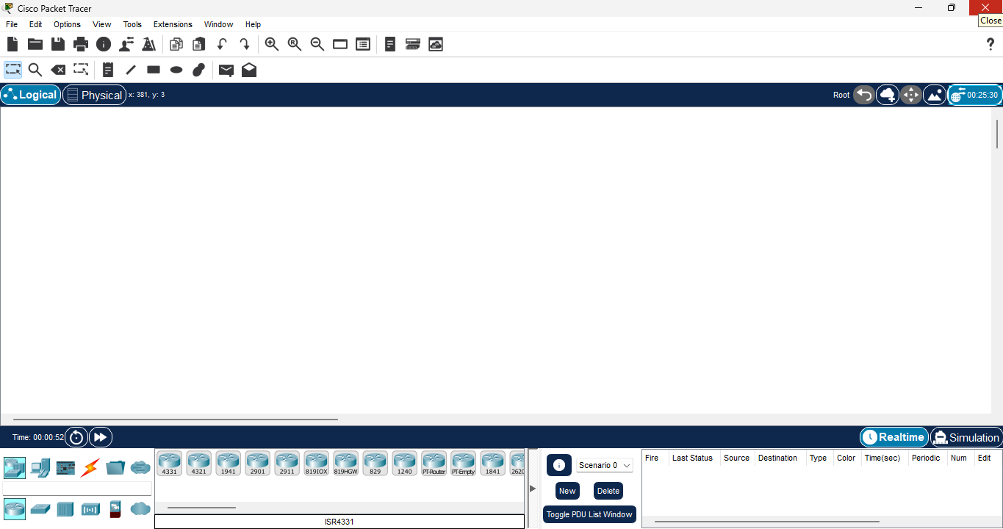
2. Add at least two PCs and one switch to the workspace. 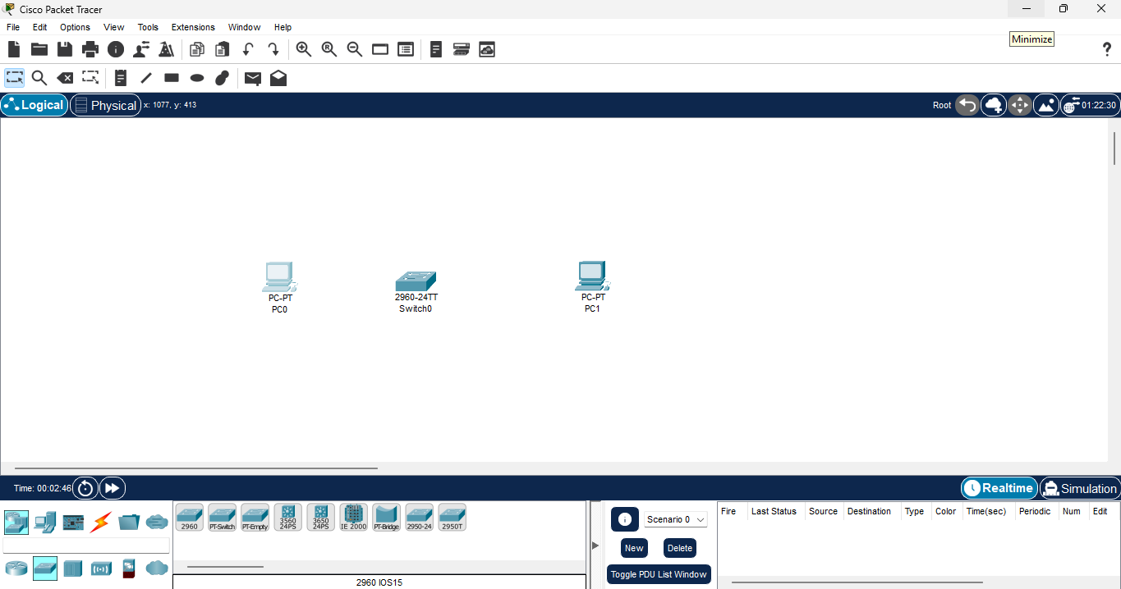

3. Connect the devices using appropriate cables.
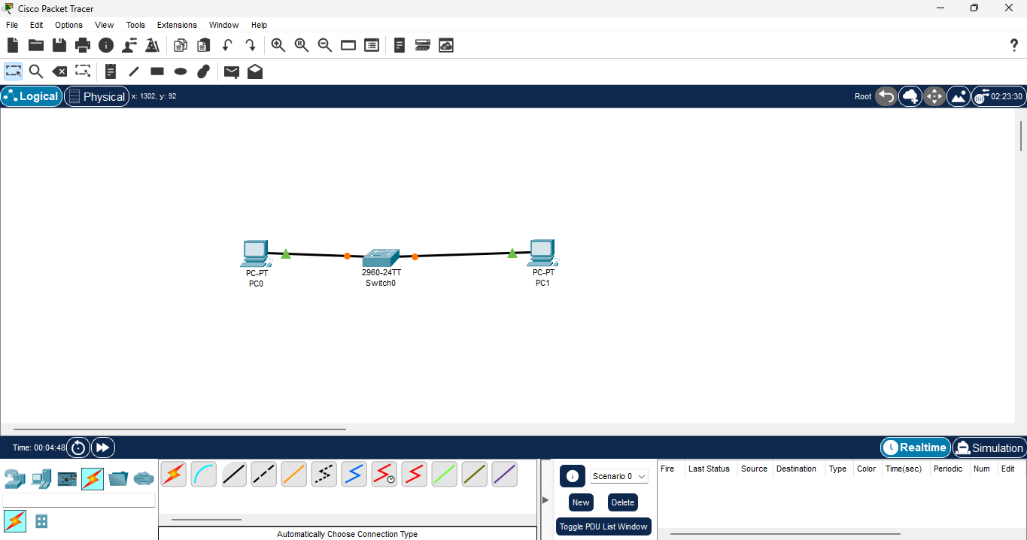
4. Assign IP addresses to the PCs (e.g., PC1: 192.168.10.2 / PC2: 192.168.10.3).
PC 0: 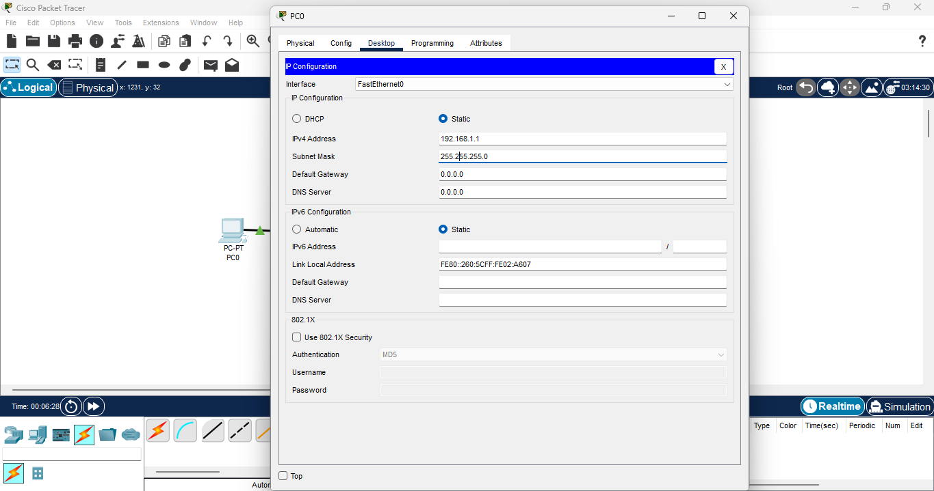
PC 1: 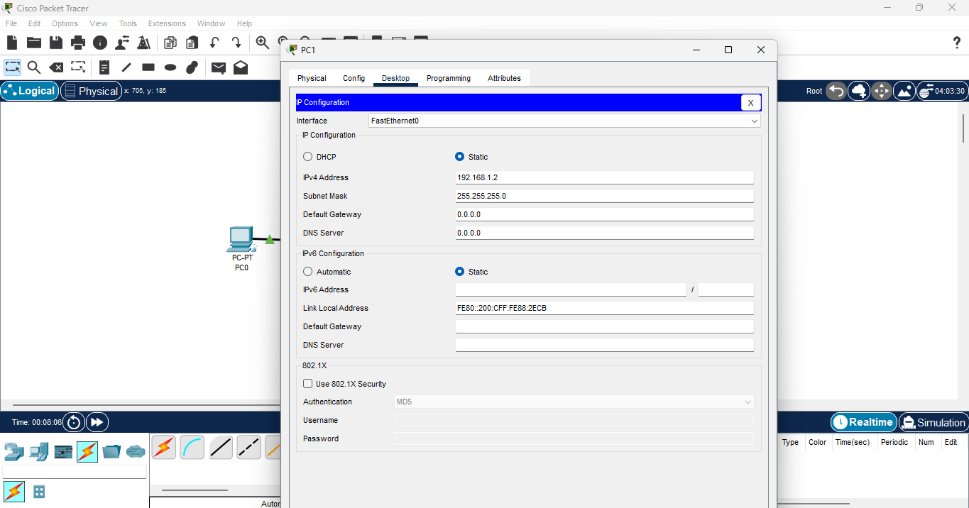

5. Verify communication between devices using the **ping** command.
PC 0 testing : 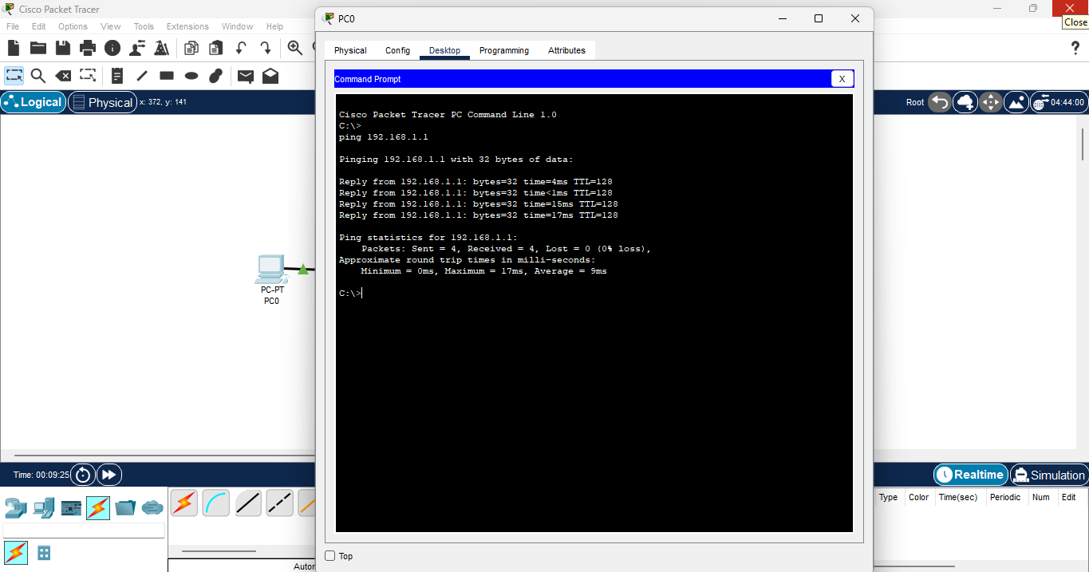
PC 1 testing: 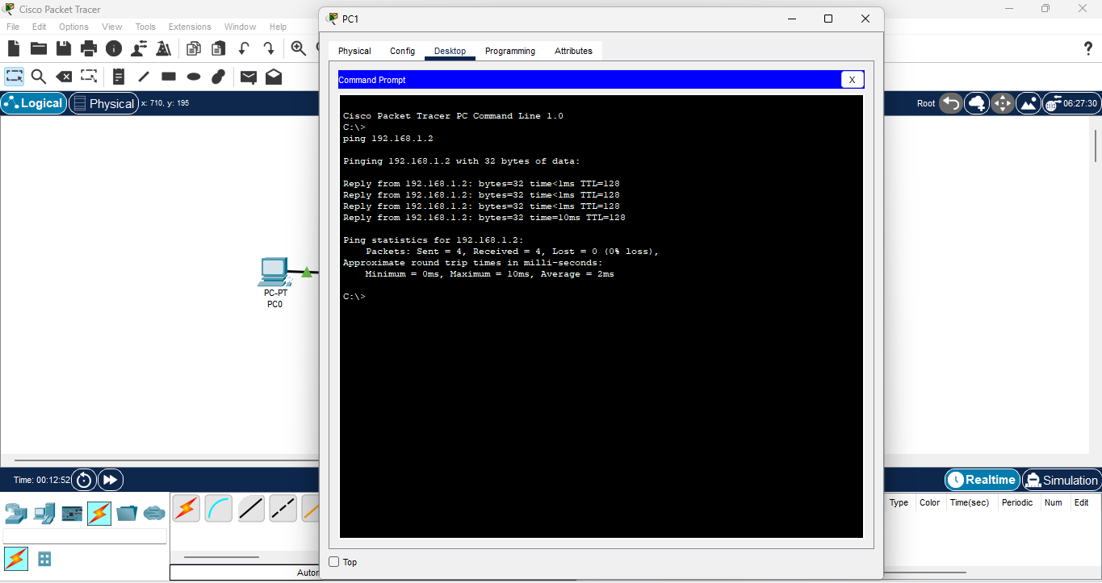

6 Switch to Simulation Mode and observe how packets travel between devices.
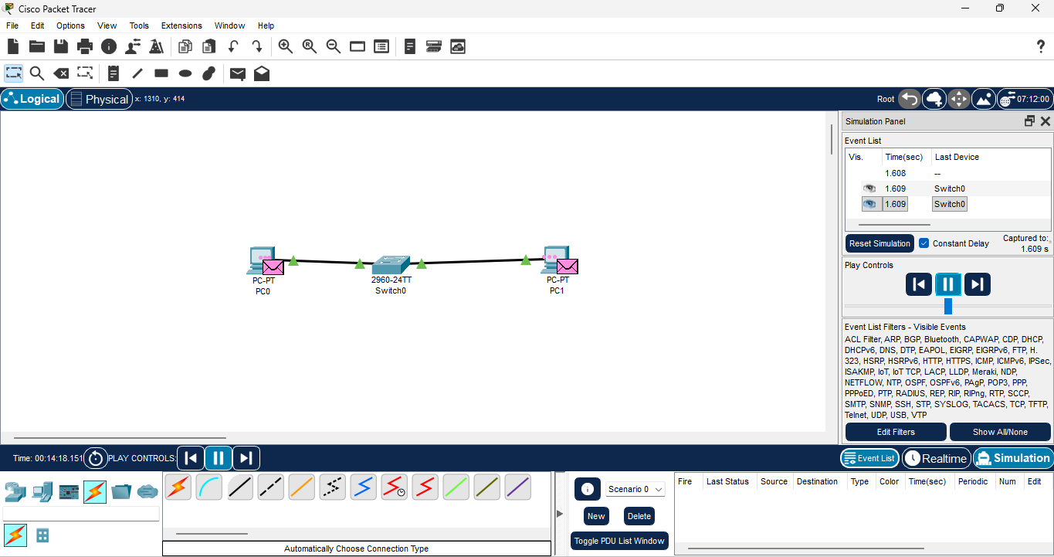

Troubleshooting Scenarios:
Students may encounter common issues such as:
• Incorrect cable type
• Devices powered off
• Missing or incorrect IP configuration
• Wrong subnet mask

They will learn to identify and resolve these problems using Packet Tracer tools and command outputs.

Expected Outcomes:
• Navigate and operate the Packet Tracer interface.
• Build a simple network using end devices and switches.
• Connect devices using correct cable types.
• Assign IP addresses correctly.
• Verify device-to-device communication.
• Use simulation mode to analyze packet flow and troubleshoot errors.

